4/21/2017

University of cincinnati

*Section: 002*

*Group Number: 007*

*Akash Jain*

*Aniket Mahurkar*

*Sourabh Munje*

*Rishikesh More*

Executive Report

Fraud Analysis for Sam’s Club

Table of Contents

1. Introduction 2

2. Background 2

3. Problem Analysis and Design 2

4. Identification of Retail Fraud and Suggested Controls 3

5. Data exploration and fraud analysis 7

Analysis of returns and sales by specific store: 7

Analysis of returns by customer: 9

Analysis of returns by item category: 11

Analysis of returns by Operator Number: 12

Analysis Based on Weekday: 15

6. Information Delivery 16

7. Conclusion and Recommendations: 21

# Introduction

The purpose of this document is to share our insights and findings on the return fraud and abuse for the Sam’s Club retail stores. We aim to identify the return frauds due to external and internal parameters that have affected the Sam’s Club retail stores and reduce these frauds by initiating controls in place. We have used Business Intelligence in performing analysis that will ensure prevention of return frauds.

The document can also be used as a white paper by any retail player focusing on mitigating the losses due to return frauds and thereby design their data warehouse for performing the descriptive analysis.

# Background

According to the National Retail Federation (NRF) 2015 Return Fraud Survey, total merchandise returns account for over $260.5 billion. Annual merchandise return fraud and abuse are estimated between $9.1 and $15.9 billion for the US Retail Industry. The figure is humongous and companies are making procedural changes like not returning cash in case of returns and introducing digital receipts to mitigate the creep in this area.

# Problem Analysis and Design

We researched the retail fraud and came up with some cases which could be possible in Sam’s Club setting. After carefully analyzing the types of fraud and the way in these frauds can happen, we devised some controls and ways to prevent these. To identify the root of these frauds based on the cases that we identified, we suggest a date warehouse solution which can be built to answers the questions related to the identification of internal and external fraud.

# Identification of Retail Fraud and Suggested Controls

External Fraud[1]:

Wardrobing – The customer uses the product and then returns it for a refund.

Stolen items being returned by the thief – The product is stolen without making a payment, and the thief returns the stolen product in exchange for cash

Non-purchased store items being returned as purchased goods – The customer takes the good off the shelf and go directly to the returns counter

Alteration of products to appear as higher value goods – change the UPC on the product and take more amount that spent on the product

Return of items purchased with a stolen or fake credit card – Purchase the items with credit card that can be used once, and then return the product for cash

Return of items using a fake or altered cash register receipt – Return a product that was never purchased from the store and present a fake receipt for exchanging the product

Goods purchased on sale are returned for original list price – Purchase the product for a lower price in sale and return the product for original price

Cross Retailer return - Purchase the product for a lower price and return the product for a higher price at a different retailer

Exchanging items repeatedly – Purchase a product, use it and keep exchanging it for a new item within the exchange days limit

Price arbitrage – Purchasing different price but similar looking merchandise and returning the cheaper item in place of the expensive one. This can happen if customer switched the price tag (UPC) of the cheaper item with the expensive item.

Switch fraud – Returning a defective item that was already owned in place of a purchased working item but with the UPC of purchased item

A Higher number of returns by a particular customer – A particular customer takes benefit of the gaps and returns products on regular basis for cash.

Internal Fraud[2]:

Employee theft and return- Employee steals items from the floor and return it later under a fictitious name or through a fake customer he knows in advance

Employees allowing the return of goods outside of the rules established by company return policies – The products are accepted for return without the receipt or complete information.

Employees give the customer too much or too little credit for the returned good – Some part of the credit like the tax credits are not returned to the customer and are kept by the employee. Or credit more than the product cost is returned to a known customer.

Employees altering records - Writing off debt or issuing customer credits when no return was made, and converting these credits to cash by the employee.

Higher number of returns for an employee- Higher number of returns when a particular employee is working

Following table provides the information about the possible fraud cases, our suggested controls for mitigating them and analytical review procedures for descriptive analysis:

|  |  |  |
| --- | --- | --- |
| External Fraud | controls | Analytic review procedures |
| Wardrobing | Check the frequency with which customer is returning | How many items returned within 5 days of purchase, that are not damaged and have price |
| Stolen items being returned by the thief | 1. Display the card which was used for purchasing 2. Scan the membership card when return initiated | Was the same membership card used for purchase and return |
| Non-purchased store items being returned as purchased goods | Check the receipt of the item at the time of purchase | Was the same membership card was used for purchase and return |
| Alteration of products to appear as higher-value goods | No control in system must be checked by the employee | The employee will have to manually check the item. Can’t be answered |
| Return of items purchased with a stolen or fake credit card | Display the card which was used for purchasing | How many records have a higher total cost that was made with the same transaction and now returned |
| Return of items using a fake or altered cash register receipt | Returning products without receipts  Check the frequency with which customer is returning | How many records have a higher total cost that was made with the same transaction and now returned |
| Goods purchased on sale are returned for original list price | Check products that have return price record more than purchase price record | How many products have return price more than purchase price |
| Cross Retailer return | Check products that do not have an item number belonging to the existing inventory | How many products have item numbers not present in the inventory |
| Exchanging items repeatedly | Check total number of returns by a particular customer | Which customer has higher or same returns as the number of purchases |
| Price arbitrage | No control in system must be checked by the employee | The employee will have to manually check the item. Can’t be answered |
| Switch fraud | No control in system must be checked by the employee | The employee will have to manually check the item. Can’t be answered |
| Higher number of returns by a particular customer | Check total number of returns by a particular customer | Which customer has higher or same number of returns than the number of purchases |

|  |  |  |
| --- | --- | --- |
| Internal Fraud | Controls | Analytic review procedures |
| Employee theft of returned merchandise | 1. Check the frequency of an employee altering records 2. Check the information of that seems to be fraudulent or incomplete | Which return records have incomplete information |
| Employees allowing return of goods outside of the rules established by company return policies | Check the completeness of the return records | Which return records have incomplete records |
| Employees allowing return of goods beyond prescribed dates | Check if return date more than the allowed exchange date | Which records have return date more than that of the allowed exchange date |
| Employees give the customer too much or too little credit for the returned good | Check if the same employee is taking return from the same customer frequently | Which records have same customer and employee appearing more than a specific percentage |
| Employees altering records (writing off debt) or issuing customer credits when no return was made | Check the frequency of an employee altering records | Which employee has number of returns on his name |
| Higher number of returns for an employee | Check if the total number of returns are more for an employee | 1. Which employee has the highest number of returns recorded 2. Which employee records return early in the morning or just before the shop closes |

Suggested DWBI Design:

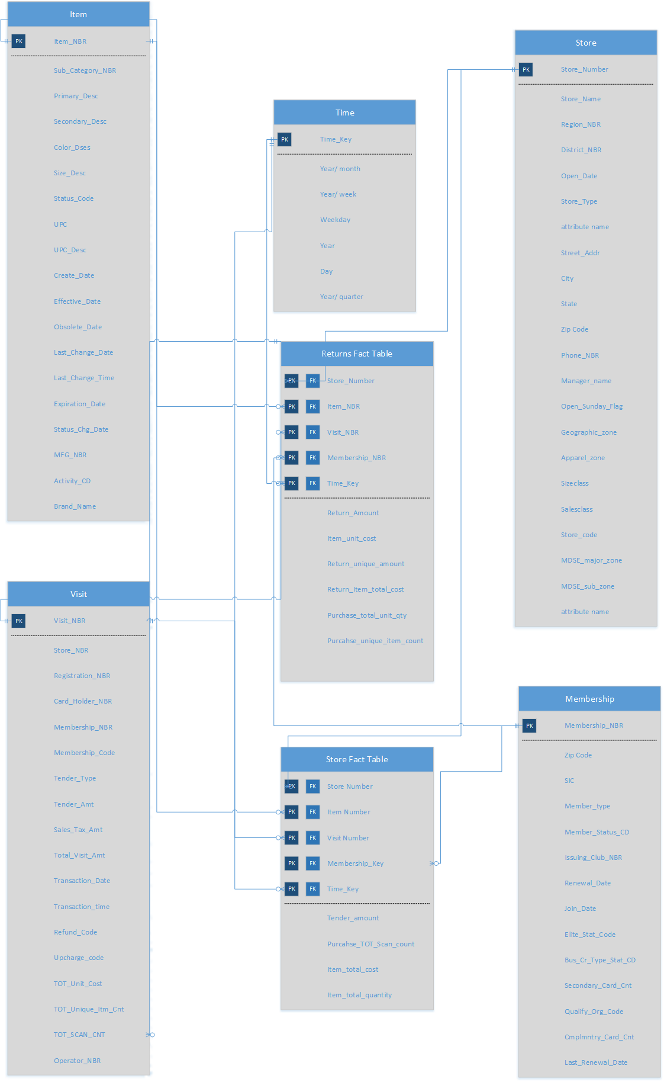

# Data exploration and fraud analysis

## Analysis of returns and sales by specific store:

The details of this analysis can be seen in the excel sheet attached with the name “Assig2_part1_query1”. After running the query UCIS7034_FRAUD_ANALYSIS_1, we realize that Purchase contributed margin total of the store 59 located in Jackson, NY is highest among all the stores and store 10 in BATON ROUGE is the smallest. But it is very interesting to observe that the average contributed capital for store 10 is very different than the rest of the stores. Store 10 has the same contribution margin as store 7. Its average contributed capital is 26. 14 as compared to 1.67 which is the average for the rest of the stores.

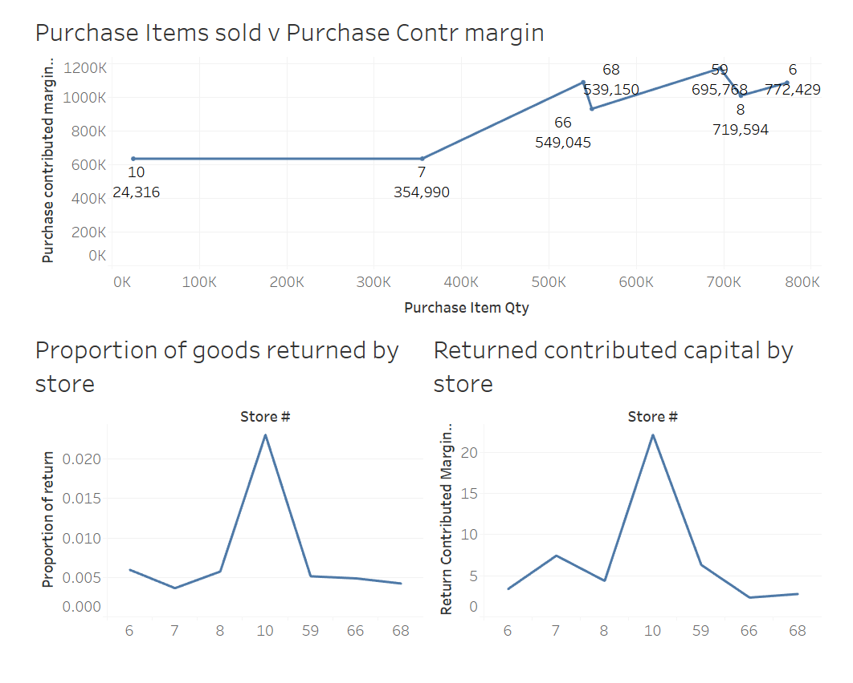

The above dashboard built using Tableau shows that store 10, which has less than 10% items sold as compared to its nearest counterpart i.e. store 7 has equal contributed capital. So, it was interesting to plot the proportion of items that were returned store wise. As we can see that the proportion of items returned in store 10 is 5 times the average of the rest. The same trend follows in the returned contributed capital.

## Analysis of returns by the customer:

After running this query, we identify few customers that may be involved in fraudulent behavior. This is a list of the set of customers following into that category that we may want to do an additional investigation about.

1. Some customers buy products from one state and return them in another, this looks especially fraudulent. These customer numbers are 4827020, 4827028, and 4827045.
2. Even within a state, there are few customers who buy and return items at different locations, it is important to be wary of these customers because these are the customers who identify to cause losses.
3. The customers who return more than 50% of the items that they buy are most of the times involved items in high volumes like 50-200 items. It is important to flag these customers because they don’t cause major losses but might be returning different than the original for the same amount of money.
4. The customers who return more than 30% but less than 50% are the customers who buy 25-50 items. This set of customers again do not cause any major losses but they may be causing other types of frauds. Like they may be returning different items than they bought or maybe they are returning the goods after using it for a while.
5. We also were able to identify certain customers who buy items at lower costs during discounts and return them during regular times at higher prices earning a margin of profit and causing losses at club house’s end. Or it is also possible that they are involved with the operator and causing these anomalies. But nevertheless, these customers should be further audited.
6. It is very important to be wary of customers without membership because it is these type of customer who is found to be returning more good than they bought causing losses. It is not just difficult to track these people it is practically impossible because we do not have much data on them. So it is a good idea to encourage customers to get memberships by using techniques like loyalty points and discounts on a regular basis.
7. Customers with type ‘W’ and ‘V’ are the customers who return more than 50% of the items they buy, they are identified to be causing heavy losses. It is very necessary that we should be wary about these customers. These customers might be returning different items than they are buying or returning them after using for a while.
8. Some of the customers are returning more than 90% of the items that we bought.

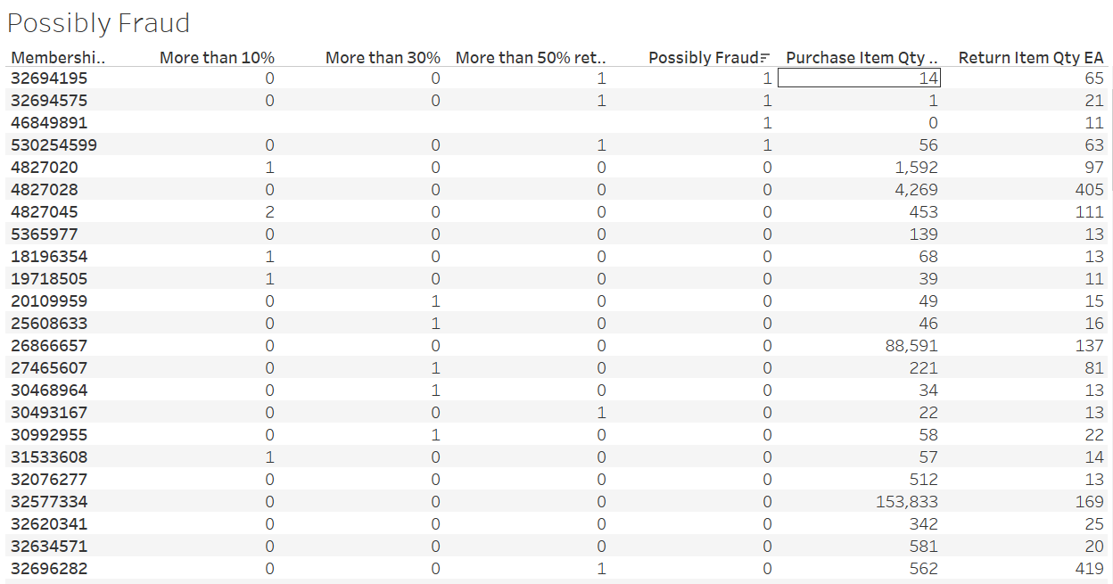

As you can see in the above table, the customers that are marked are possible fraud are the customers who are returning more items than they are buying. There is a good chance that they are fraudulent and the club should be wary of them.

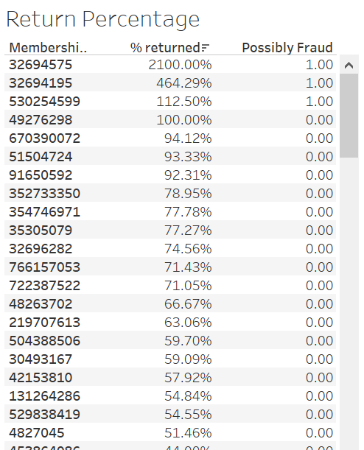

In the above table, we can see a few customers that have really high percentages of returns and could possibly be fraudulent. The club should have a special type of the customers who fall into this category and pay special attention or store additional data regarding the transactions that they are making.

## Analysis of returns by item category:

After running a query to get results for items returns by item category, we realized that the top 3 categories that experience most return viz. Electronics communications, Vision Wear, and School Supplies make up to 45% of the total returns. In the further steps, we analyze data based on the results for these 3 categories only. Now it is important to note that store 10 again accounts for the highest percent of returns.

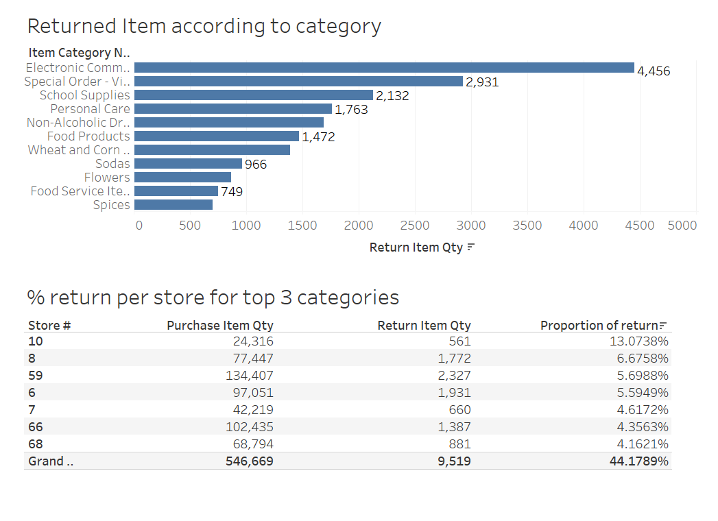

If we filter the data according to the category we see that 10% of the items from the Electronics Communications category are returned at the store 10. Though the count is just 22 but the percent look high and may be fraudulent. The club should especially be wary of such visits because 22 being a smaller number could be neglected easily, but percentage wise it is more than three its closet comparable store. These products make up to a very high contribution margin and the return of these products are of monetary value.

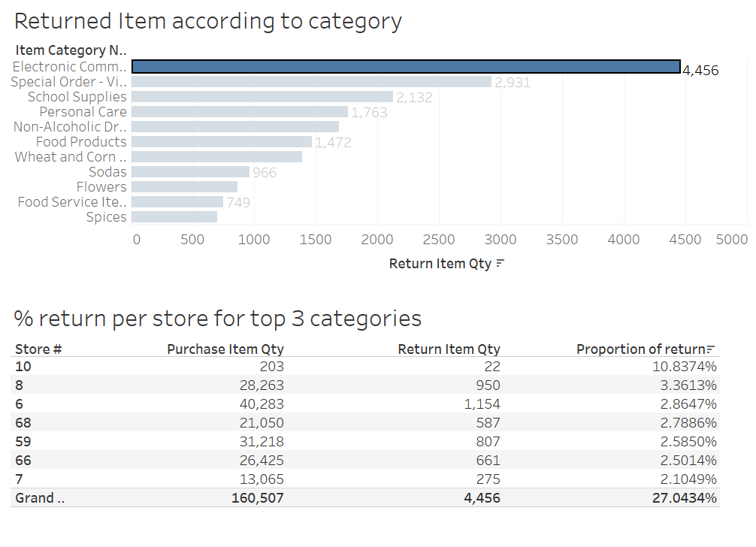

## Analysis of returns by Operator Number:

Frauds can be external as well as internal, till this point we have been analyzing external sources of fraud. Now moving on to internal sources of frauds we perform analysis of returns based on operator number. For this purpose, we move on from Line item infocube to store visit infocube. This data gives a brief idea of the individual visits in the data. Exploring data for this purpose here are few results that we found out to be interesting.

First, We tried to find out the operator numbers who were involved with the most number of items returned.

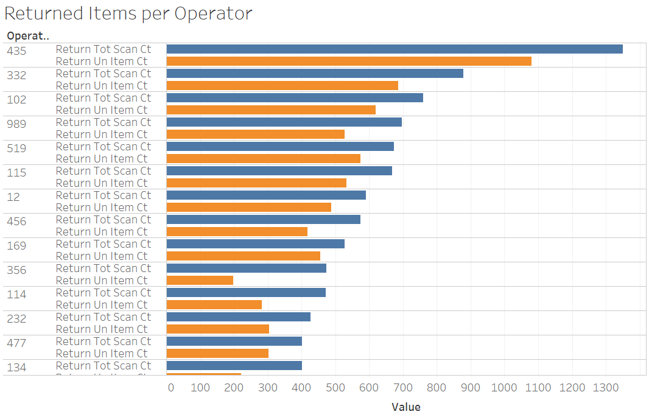

As we can see in the above visualization, operator number 435, 332, 102, 989, and 519 cause the most number of returns in the club. But operator number 435 has an abnormally high number of returns. It may be possible that this operator may be involved in fraudulent transactions. It also might be possible that some other operators are using 435’s credentials to authorize fraudulent transactions. The working hours of this operator must be cross referenced with the day and time of these transactions.

Second, we try to find out the operator number that is involved with the return that has highest money values. This might be a good approach to go through the data for fraud analysis as the primary purpose of any fraud is for financial benefits.

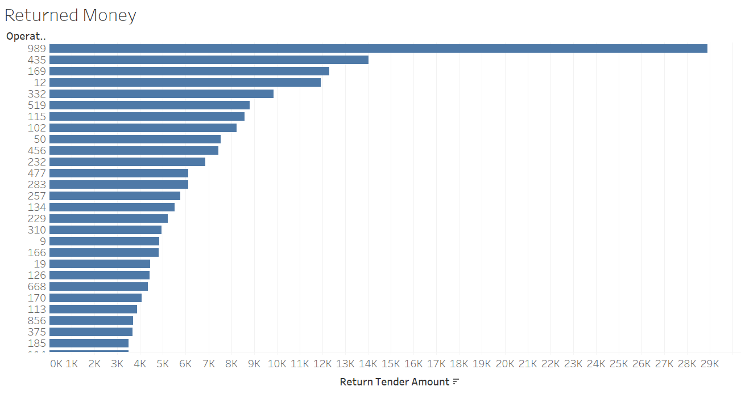

From the above visualization, we observe that operator number 989, 435, 169, 12, and 332 are involved with highest returned the money. It is important to look into these operator 989 and 435 as they are involved in highest number and highest values of returns.

Operator 989 work at store 10 which is in Baton Rouge. From the earlier part of our analysis, we know that store 10 has given us enough reason to have a suspicion that there might be something fraudulent going on at the place. This operator, in particular, is involved with 696 items which are 4th highest among all the operators but the amount they this operator is involved with is very high, the Club should be wary of this operator and check the transaction that he authorizes or may be even blocking the operator temporarily from authorizing any more high value returns.

Operator 435 works at 2 locations Jackson city and Atlanta. But it is very interesting to note that all the returns that he is involved with are only authorized from Atlanta and none from Jackson City. There is a chance that the operator might have been part of an incident there and is blocked from authorizing any returns. But it can also be observed from the data that Jackson City has 80,000$ unaccounted money which is alarming. There is a chance that he authorized returns at Jackson City as well and the data for the operators returns from this location is missing adding up to the unaccounted money. This fact should be investigated with the highest priority.

## Analysis Based on Weekday:

It was specifically very interesting to note the trends that effect the item's purchase and returns based on day of the week.

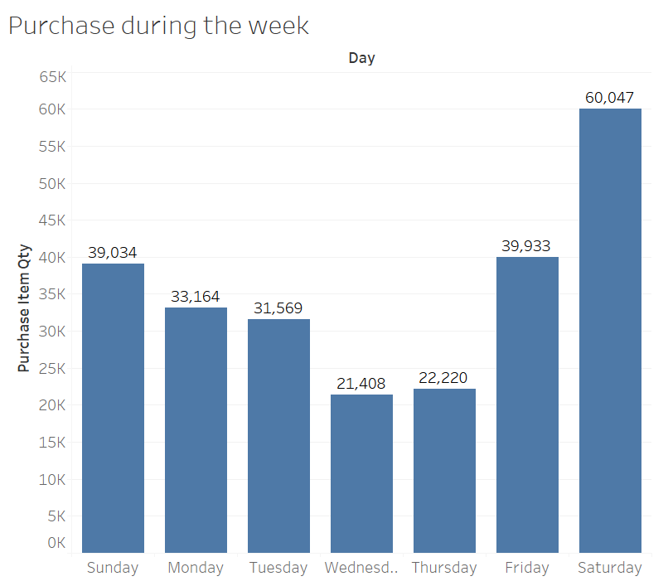

The visualization above shows the purchase trends of the week. As we can see, the purchase are highest at the weekends peaking on Saturday and fall down gradually as the week progresses. Wednesday is least busy with the least number of items sold.

On the contrary, the returns are least on the weekend and progressively increase as the week progresses. Highest returns occur on Thursday and slow go down on the weekend. It is very interesting to know that the least returns occur on Monday instead as expected on Sunday.

The visualization below gives a brief idea of the trend of returns.

There is a very integrating fact to note that the store 10, which has raised the most suspicion, work only on weekdays and is closed on weekends. From the day it is very clear that the busiest and profitable days are the weekend so makes no sense to close the store on weekends. Additional attention should be paid to this since this raises suspicion.

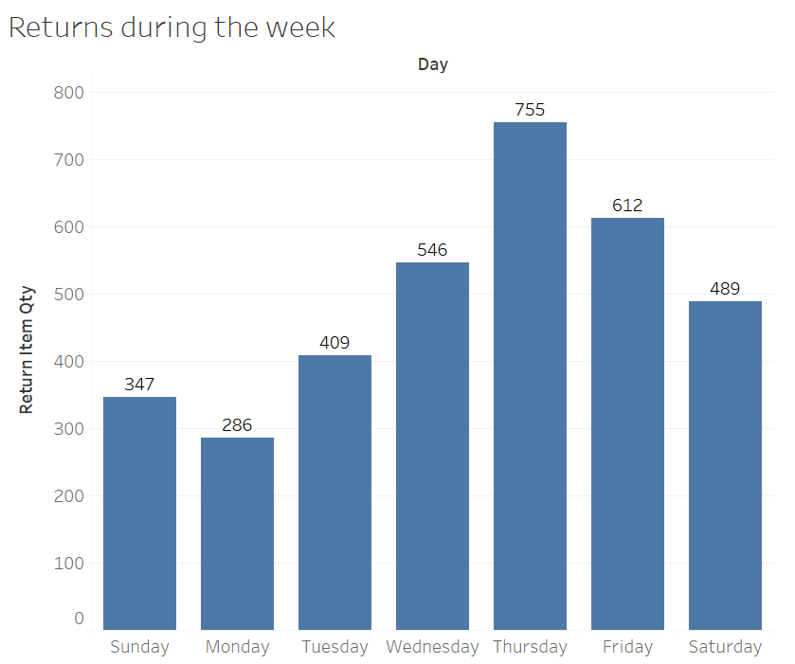

First and foremost, we tried to understand the various roles and the number of users associated with those roles on the network.

# Information Delivery

To the analysis, we went through a number of combinations of Dimensions to find out the anomaly.

We started by checking it for the Item Number.

We found the following anomalies which can be in the category of a potential fraud.

1. We found that the printing material was often replaced and this could be a case where the item could have been used and returned. It is also possible that the users may have used some print pages and replaced the rest of the set of pages. For example, the item number 164097 has been replaced more than 5% of the times and that product is “8.5 X 14 PREMIUM*20#C PAPER 5000 SHT”.

Similarly, the other product is “FILE FOLDERS 100 CT.LEGAL SIZE MANILLA” which can be used and replaced later and we find that it being replaced more than 9% of the time. The same goes for many other office supplies. Similar is the case with 78104.

This should be checked whether the users are deliberately trying to use and replace these products.

1. Then for some products like flowers which cannot be replaceable after a couple days at max, we noticed that they were replaced even after 2 weeks. Item Number 2764510 which is “EASTER LILY5 7 BLOOM” has been replaced after two weeks. So, such cases need to be checked for Operator fraud because such a scenario cannot be done without insider help. This product has been replaced more than 29% of the times.
2. Products like 2529141 “WEDDING PARTY PACKONE TIME USE CAMERA” or other products which are used on celebrations or festivals have the chance of being replaced a lot because people do not require those after a couple of days. This has been replaced 5.3% of times.
3. A category type caught our attention was Cordless phones. A lot different type of cordless phones was replaced. We could not find the exact reason for that but one potential reason could be people were replacing their used Cordless phones. Item Number 1013118 which is “TELEPHONE CORDLESS2-LINE” has 7 replacements for 7 purchases. That is 100% replacement. Either the product is buggy, or people use and replace the products.
4. We also have a perishable product 132936 which is “HAMBURGER BUNS2-12 CT” and has been replaced for more than 21%. Also, one week shows 27 purchase and 54 return which is near twice the purchase. So, either it is a fraudulent case or the previous weeks purchased the product has been replaced.
5. Another Item Number 2792281 “AUTOMATIC PAPERSHREDDER W/BASKET” has an anomaly on its replacement. When we see the first week of the data provided, we see that it has 4 replacements. So, either we do not have the previous data when it got sold, or this is a potential fraud. Also, when we check all the data for next 5 months, we see that the total replacement for this product has been 10 times and the purchase has been 3 times. We also see that the product costs 42$ but is sold for 24.59$. This can be an insider job where someone is selling at low cost and replacing more products than sold.
6. A product 3056378 which is “900MHZ TELEPHONEW/HEADSET” was sold for 5 times and returned for 10 times in a span of a year. This can be a potential case where we can find a fraud because the twice number of products were replaced as much they were sold.

After checking the Item Number, we checked the Member type of the customers and checked the replacements for them.

We see that there is the difference in the replacements done by each category of customers.

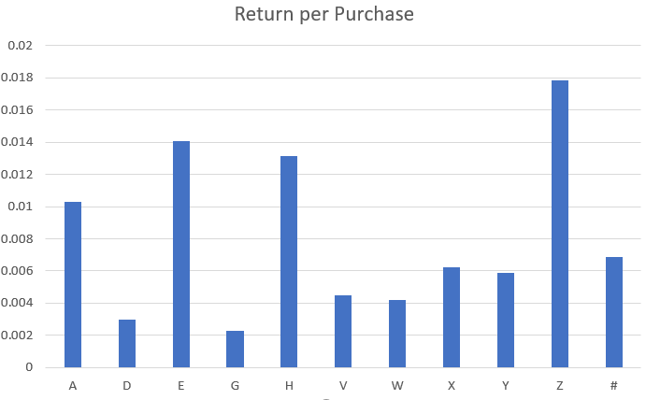

So, Z has a higher amount of replacements ratio when compared with other groups. We should be checking the transactions and return trends for this group. So, this was the ratio of returns, but we can also check the number of replacements.

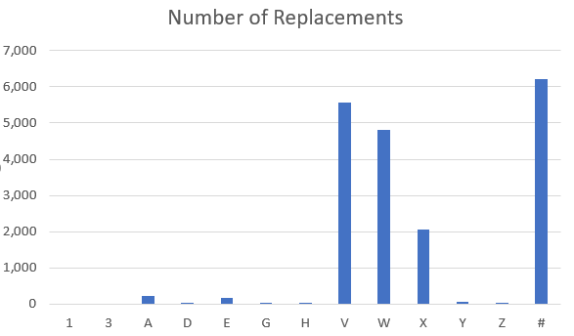

After covering this, we tried checking the Stores for some anomaly at a specific store.

For doing this we checked the return per sale ratio for all the stores and we found out that the return rate is near to 2.31%, whereas the normal rate of replacement for other stores is nearly 0.52%. This anomaly can be seen easily by using a line chart for all the stores.

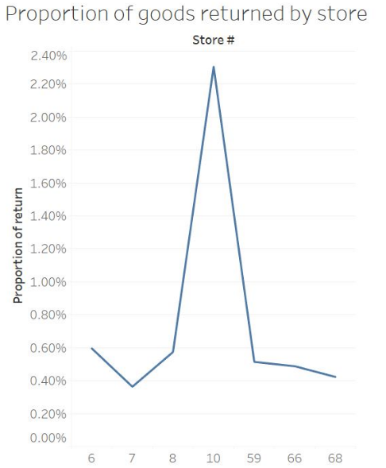

We can say that there is a difference in the way this store operates and on checking this can be found to be a potential fraud.

We then thought of going through the operators to check if there is some insider fraud or fraud by operators. To check this, one way can be to check the returns for all the operators. The ones which have high return ratio, the chance is either his way of working is different, or there is a potential fraud involved in it.

To do this analysis we made a horizontal bar chart where we can compare the return ratios for the operators.

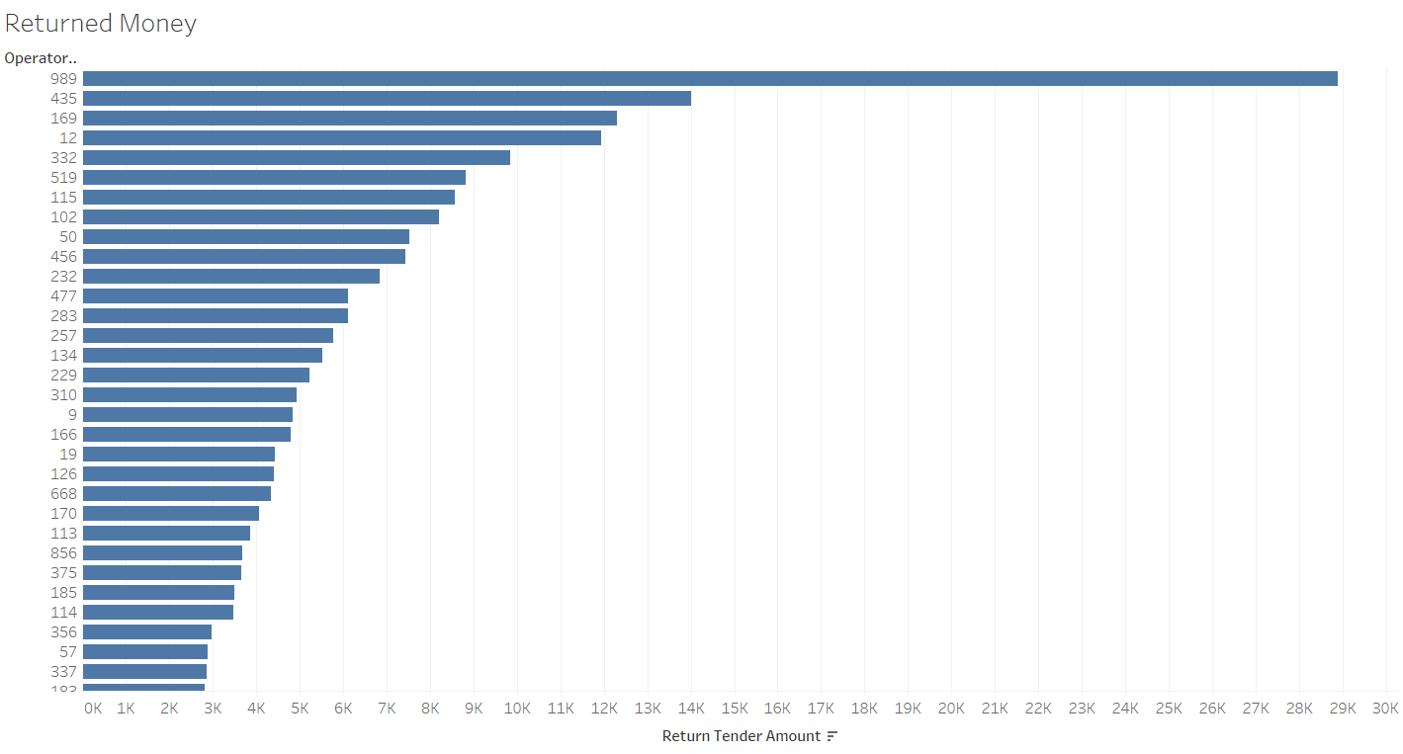

Looking at this chart, we see that the operator 989 has processed a lot of returns. So, this can give us an insight into which operators needs to be checked for potential fraud issues. At least top 10 operators have a very high ratio of return and look unnecessary.

We also notice that the operator 989 returns the highest to Member Type Category X. Whereas the operator 435 which is second highest return processing operator returns highest for Member Type Category W. So, we cannot directly see the pattern but it can be possible that an operator works specifically for a Member Type Category.

# Conclusion and Recommendations:

Based on our analysis, there are clearly cases of fraudulent activities spawning everywhere in Sam’s Club. The higher management will have to change certain policies to have a tighter grip on the returns and sales. Following are the measures that the senior management should consider:

1) Design strict return policies that should govern the maximum time a customer can return the product that they have purchased

2) Encourage customer membership plans by giving discounts so that it is easier to manage the returns as sales. This will help the company in reducing fraudulent sales because the maximum number of returns are done by people which are not members of Sam’s club

3) Policies should be enforced to make sure that no returns should be allowed without the purchase receipt and membership card

4) Since the maximum number of returns doesn’t have information about the operators who dealt with them, stronger controls should be enforced in the system to make sure that returns are only being managed by Operators

Sam’s Club has the data and infrastructure, they just need to impose some strict policies to cope up with these cases. The DWBI infrastructure that they are using can be improved by including information about products to a greater detail and it should also be given the capabilities to support real time reporting and managers can use this real time reporting to stop the fraud from happening.

1. Sources: <https://www.consumeraffairs.com/retail/sams_club.html>

   <https://www.samsclub.com/sams/pagedetails/content.jsp?pageName=returns>

   ifpo.org

   nationalretailfederation, Press Releases
2. Sources: <https://www.consumeraffairs.com/retail/sams_club.html>

   <https://www.samsclub.com/sams/pagedetails/content.jsp?pageName=returns>

   ifpo.org

   nationalretailfederation, Press Releases